EX NO: 4

15/09/2021

**UDP CLIENT- SERVER PROGRAM**

**TO GENERATE THE PAN NUMBER**

**AIM:**

To create a socket programming to develop a UDP client server program to generate the PAN number for client whose name and surname are passed to the server.

**ALGORITHM:**

**SERVER:**

1. Include header files, initialize the required variables and specify the family, protocol, IP address and port number.
2. Create a socket using socket() function.
3. Bind the IP address and port number and listen to the client’s request for connection.
4. Read the client’s message as a string.
5. Perform the function to create a PAN card number for the received data.

**CLIENT:**

1. Include header files, initialize the required variables and specify the family, protocol, IP address and port number.
2. Create a socket using socket() function.
3. Call the connect() function and scan the input message.
4. Send the input string to the server.
5. Display the received PAN card received from server.

**PROGRAM:**

**SERVER:**

#include <stdio.h>

#include <netdb.h>

#include <netinet/in.h>

#include <stdlib.h>

#include <string.h>

#include <sys/socket.h>

#include <sys/types.h>

#include <unistd.h>

#include <arpa/inet.h>

#include <time.h>

#define MAXLINE 1024

#define SA struct sockaddr

void pancard(char firstname, char surname, char *pan){

srand(time(0));

char num[]={'0','1','2','3','4','5','6','7','8','9'};

int i,j;

char use;

printf("Enter P for personal use and G for Business use:");

scanf("%c",&use);

for(i=0;i<3;i++)

pan[i]=rand()%27+65;

pan[i++]=use;

pan[i++]=surname;

for(j=0;j<4;j++)

pan[i++]=num[rand()%9];

pan[i++]=firstname;

pan[i]='\0';

}

int main(){

int sockfd,a,n;

char pan[10];

socklen_t len;

char msg[1024];

struct sockaddr_in servaddr,cliaddr;

len=sizeof(cliaddr);

sockfd=socket(AF_INET,SOCK_DGRAM,0);

if(sockfd<0){

printf("\nError in opening the socket...");

exit(0);

}

printf("Socket opened successfully...");

bzero(&servaddr,sizeof(servaddr));

servaddr.sin_family=AF_INET;

servaddr.sin_addr.s_addr=INADDR_ANY;

servaddr.sin_port=htons(8080);

printf("\n\nBinded");

bind(sockfd,(SA*)&servaddr,sizeof(servaddr));

printf("\n\nListening...\n");

bzero(msg,MAXLINE);

n=recvfrom(sockfd,msg,MAXLINE,0,(SA*)&cliaddr,&len);

printf("\nMessage received from Client: %s\n",msg);

char firstname=msg[0],surname;

for(a=0;a<strlen(msg);a++){

if(msg[a]==' '){

surname=msg[a+1];

break;

}

}

pancard(firstname,surname,pan);

printf("Generated PAN Number: %s",pan);

printf("\n");

sendto(sockfd, (const char *)pan, strlen(pan), MSG_CONFIRM, (const struct sockaddr *)&cliaddr,len);

return 0;

}

**CLIENT:**

#include <netdb.h>

#include <stdio.h>

#include <stdlib.h>

#include <string.h>

#include <sys/socket.h>

#include <sys/types.h>

#include <netinet/in.h>

#include <unistd.h>

#include <arpa/inet.h>

#define MAXLINE 1024

#define SA struct sockaddr

int main(){

int sockfd, n;

socklen_t len;

char sendline[1024], recvline[1024];

struct sockaddr_in servaddr;

sockfd=socket(AF_INET,SOCK_DGRAM,0);

if(sockfd<0){

printf("\nError in creating the socket...");

exit(0);

}

printf("Socket created successfully...");

bzero(&servaddr,sizeof(servaddr));

servaddr.sin_family=AF_INET;

servaddr.sin_addr.s_addr=inet_addr("127.0.0.1");

servaddr.sin_port=htons(8080);

connect(sockfd,(SA*)&servaddr,sizeof(servaddr));

len=sizeof(servaddr);

bzero(sendline, sizeof(sendline));

printf("\nEnter your name and surname: ");

n = 0;

while ((sendline[n++] = getchar()) != '\n');

n=sendto(sockfd,sendline,MAXLINE,0,(SA*)&servaddr,len);

if(n<0)

printf("\nError in sending message[sendto]...");

strcpy(recvline,"");

n=recvfrom(sockfd,recvline,MAXLINE,0,NULL,NULL);

recvline[n]='\0';

printf("Received PAN Number: %s",recvline);

printf("\n");

if(n<0)

printf("\nError in receiving message[recvfrom]...");

return 0;

}

**SAMPLE OUTPUT:**

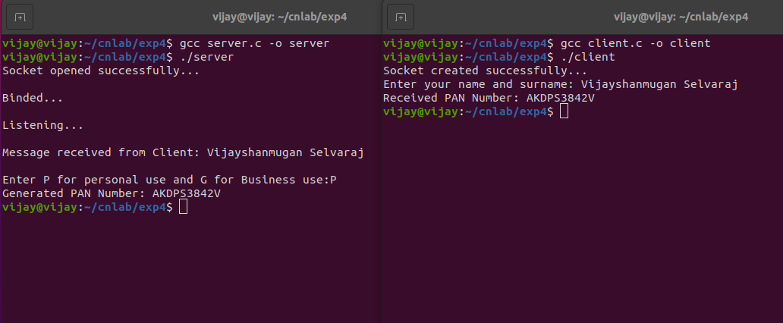

**RESULT:**

Hence the UDP client server application was created to generate the PAN number and the output was verified.